**LAB#10**

**Who am I?**

I can be any person office worker, house wife, teenager, sport person, musician and can related with any profession. Minimum age:16 => Maximum age: 55 because of generation gap 55 above all are not really interested in this online gift shopping because they spent most of his/her life by purchasing item through directly to the shop (physical presence) I shop.

**Theme:**

In today’s world people are so busy that they do not have enough time to meet their relative, family members, friends and love ones who lives in other countries or cities to meet with them on each month or twice or thrice a year or to meet with them on occasions like ‘Eid, Christmas, Diwali, Holi, Birthday, New year, if they are so busy or have some other issues so if they cannot be able come so they send gifts to their love ones instead. So I need a system (software, app, web app) through which I can easily able to send customized gift surprises to my love ones, friends and family easily.

**Stakeholders:**

Customer, delivery boys or riders, multiple suppliers, multiple distributors, Company owner and staff, Bank

Problems:

1. How payment can be done
2. How to contact someone who sends gifts on behalf of us
3. How to send gift without any time waste.
4. How to send gift without any p payment issues
5. Gift quality issues
6. Gift quality of not being damaged until the receiver gets it
7. How can we able to give order
8. How can we customized things
9. How can we assure that gift has received
10. How can we see when parcel is dispatched and in between delivering process

Solutions:

1. To make app where customer easily choose customized gift from anywhere, any brand, any shop and any vendors and send to their love ones with chosen payment method choices.
2. To make an app where customer can see shops, vendors, company and in which we are collaborated with and offer our services only using those brands payment method would be same

**Screens:**

**1 2**

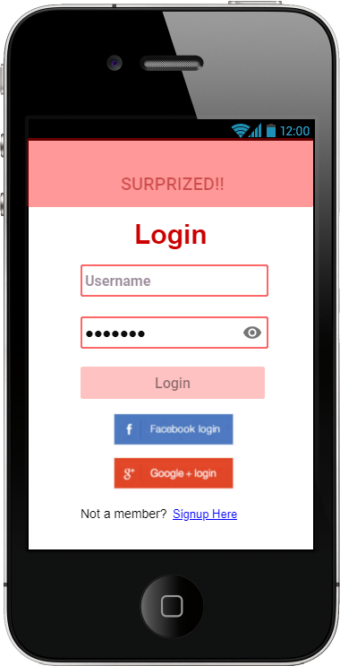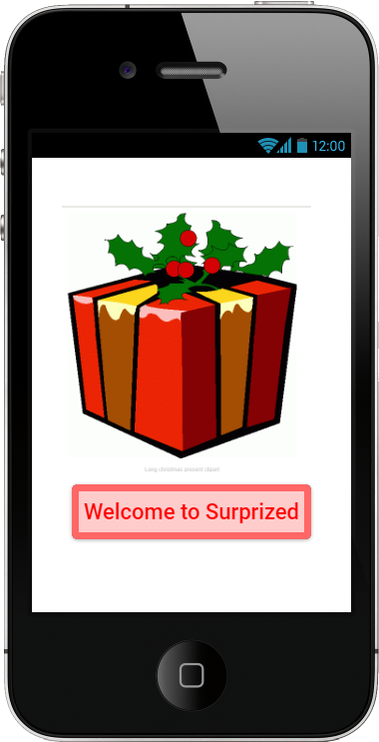

**3 4**

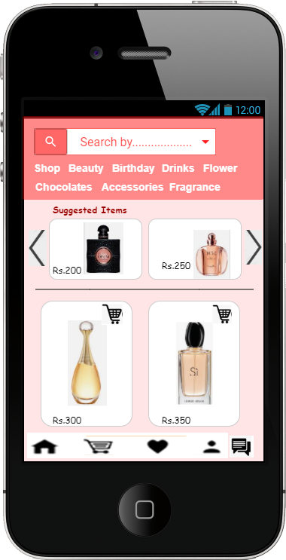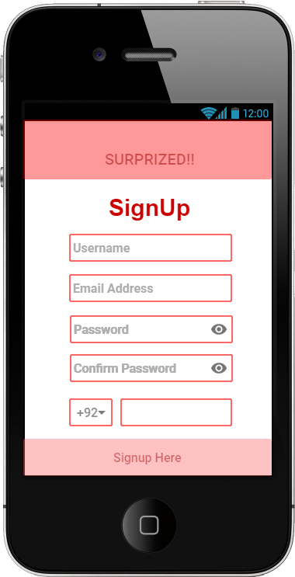

**5 6**

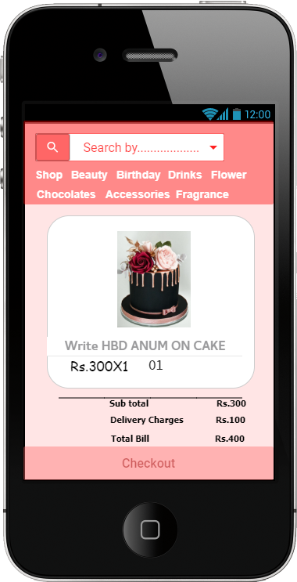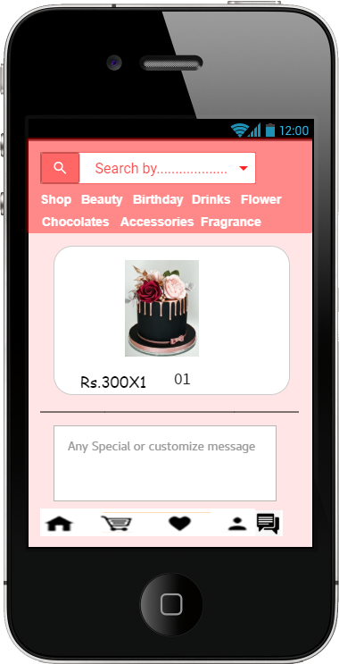

**7 8**

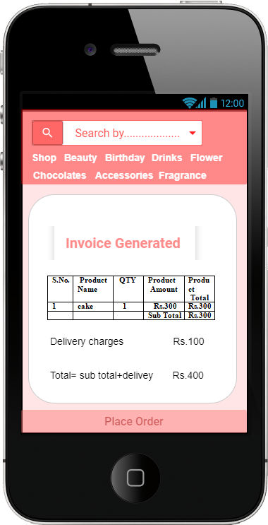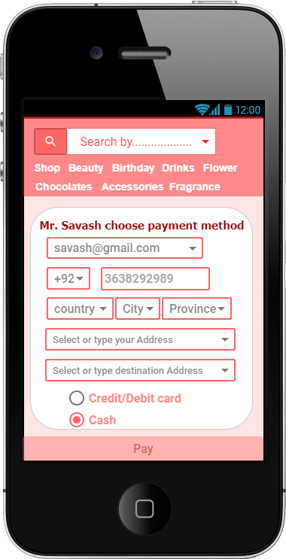

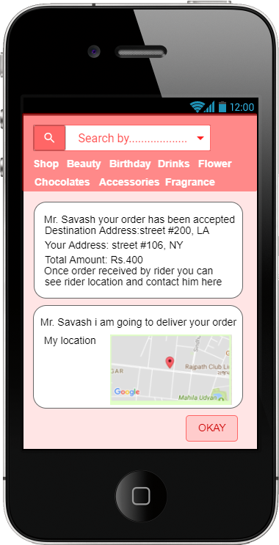 **9**